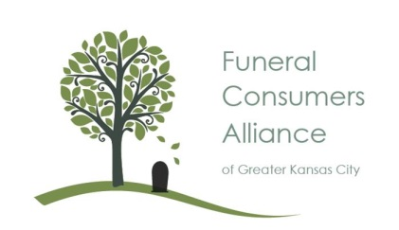
FUNERAL CONSUMERS ALLIANCE- GKC ANNUAL MEETING
Friday, NOVEMBER 4, 2016
3 PM TO 5 PM (Check In at 2:45 PM)
KAUFFMAN CONFERENCE CENTER
4801 Rockhill Rd, KCMO

2 HOURS FREE CEU FOR SOCIAL WORKERS

WHAT TO DO BEFORE DEATH, AT TIME OF DEATH, AFTER DEATH
BEFORE DEATH: PRE-PLAN DISPOSITION OF BODY -TRADITIONAL, CREMATION, NATURAL, HOME OR BODY DONATION-HOW TO PREPARE A “DEATH FILE” WHAT LEGAL DOCUMENTS DO YOU NEED
AT TIME OF DEATH: WHO TO CALL -BODY PREPARATION FOR HOME FUNERAL
AFTER DEATH: LEGAL PAPERWORK-PROBATE-WHAT’S NEXT?
Register at: www.eventbrite.com search Funeral Consumers Alliance-GKC Annual Meeting
